- CCR Feedback and Testimonies -

Thank you again for conducting such a wonderful meeting today. I gain so much from listening to those that have gone before me. I haven’t had to look for a job in 25 years and a lot has changed. It can be very overwhelming to a novice. But CCR makes the process easier. It's definitely a place to feel at ease and have hope.
Kay

Thank you for the opportunity to visit with you at Saturday's roundtable. I visited the job club two weeks ago and am impressed by the quality and organization of the meetings. I am thankful the human resource representatives donated their valuable time and insights.
Valarie

I just wanted to take a minute to thank you. First for starting the group CCR, next for playing such a big role in shaping its path, and last for being there for support and guidance. The group has become a big part of my life. It is not just a group to me its family. I can’t put it into words or if I did put in into words give it its rightful justice. Just want to say a BIG THANK YOU to you for being YOU. I will always be a part of this group for many years to come.
Sam

Thank you so much for all you do to facilitate the Catholic Career Roundtable and for arranging the panelists. Saturday was my first experience with the group and I hope I will have the opportunity to attend more of your events to strengthen my networking abilities.
Debbie

I attended CCR this morning for the first time and just want to extend my gratitude for this group. I'm feeling much better about my job search and have already made some wonderful connections. I'm so thankful this resource is available to me.
Jill

After one of your roundtables, I was able to meet an HR representative from Waddell & Reed. Two months later, I got an interview there. I had six interviews in two days and got a job offer on the third day. I know it was God who organized it all! Thank God for the opportunity to be a part of Catholic Roundtable and my job at WDR.
Yolanda

CCR History of Prayer Pictures

Each CCR meeting, we open with a prayer for our job search. We close each meeting with a prayer for all those who need our caring thoughts with special intentions for all of the people listed on the CCR prayer board. Two years ago, we started taking pictures of those who needed our support. We then deliver the picture with a message, “Today we prayed for you.”

The CCR prayer pictures have not only gone to numerous recipients locally but as far as California, Virginia, Arizona, Missouri, North Carolina and even to Moscow.

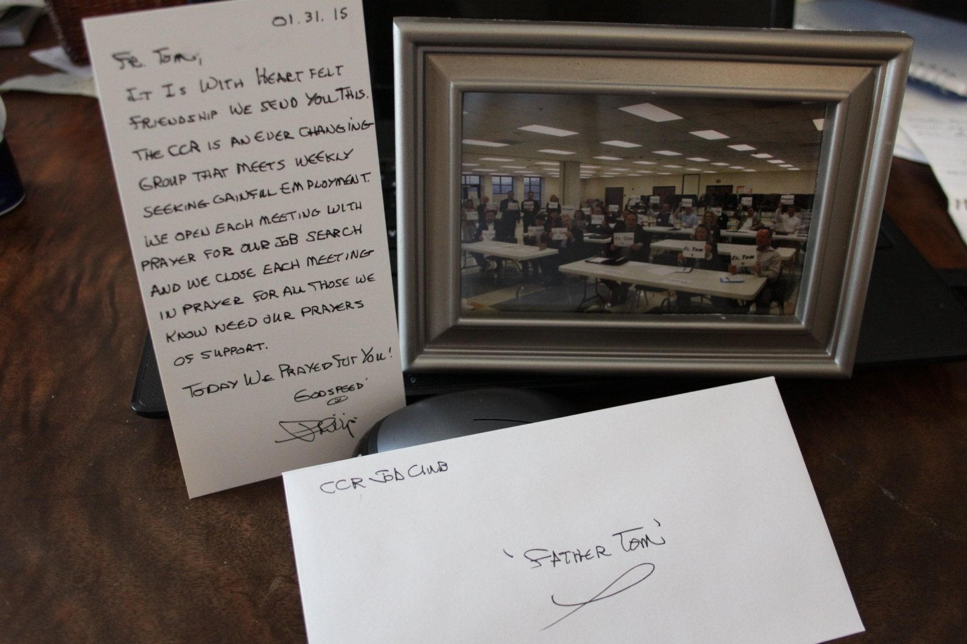

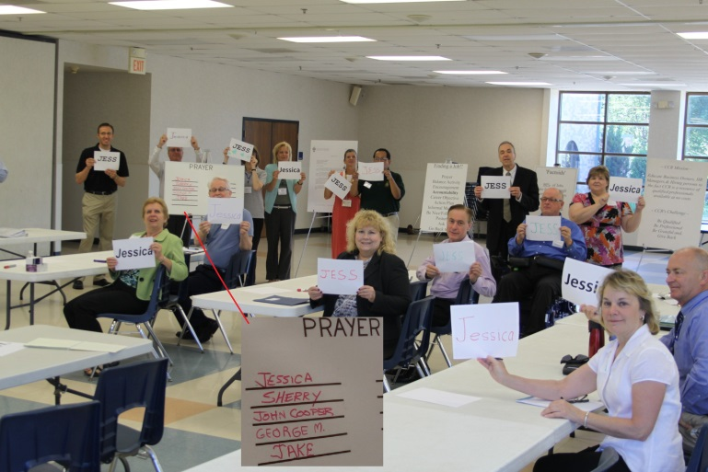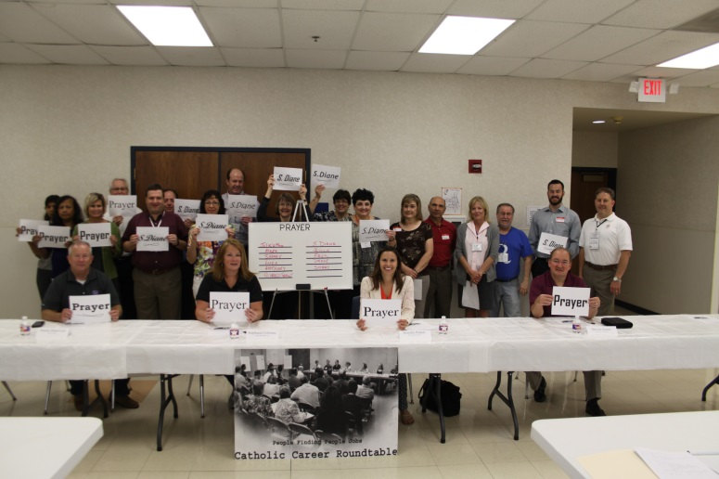

Comments:

I'm overwhelmed with your kindness and am in tears. You are my sincere Blessing. Thank you to everyone in the CCR group for the prayer picture. I have it here on my dresser, and I am taking it to my next treatment to share with doctor and nurses.
Deb

This means so much. The prayers must be helping because his blood numbers are improving as of today.
Janelle

Thank you for the picture, this is awesome! My wife will cherish it.
Richard

